New Mexico Environment Department  Air Quality Bureau  525 Camino de los Marquez, Suite 1  Santa Fe, New Mexico, 87505  Phone (505) 476-4300  Fax (505) 476-4375  www.env.nm.gov/aqb | 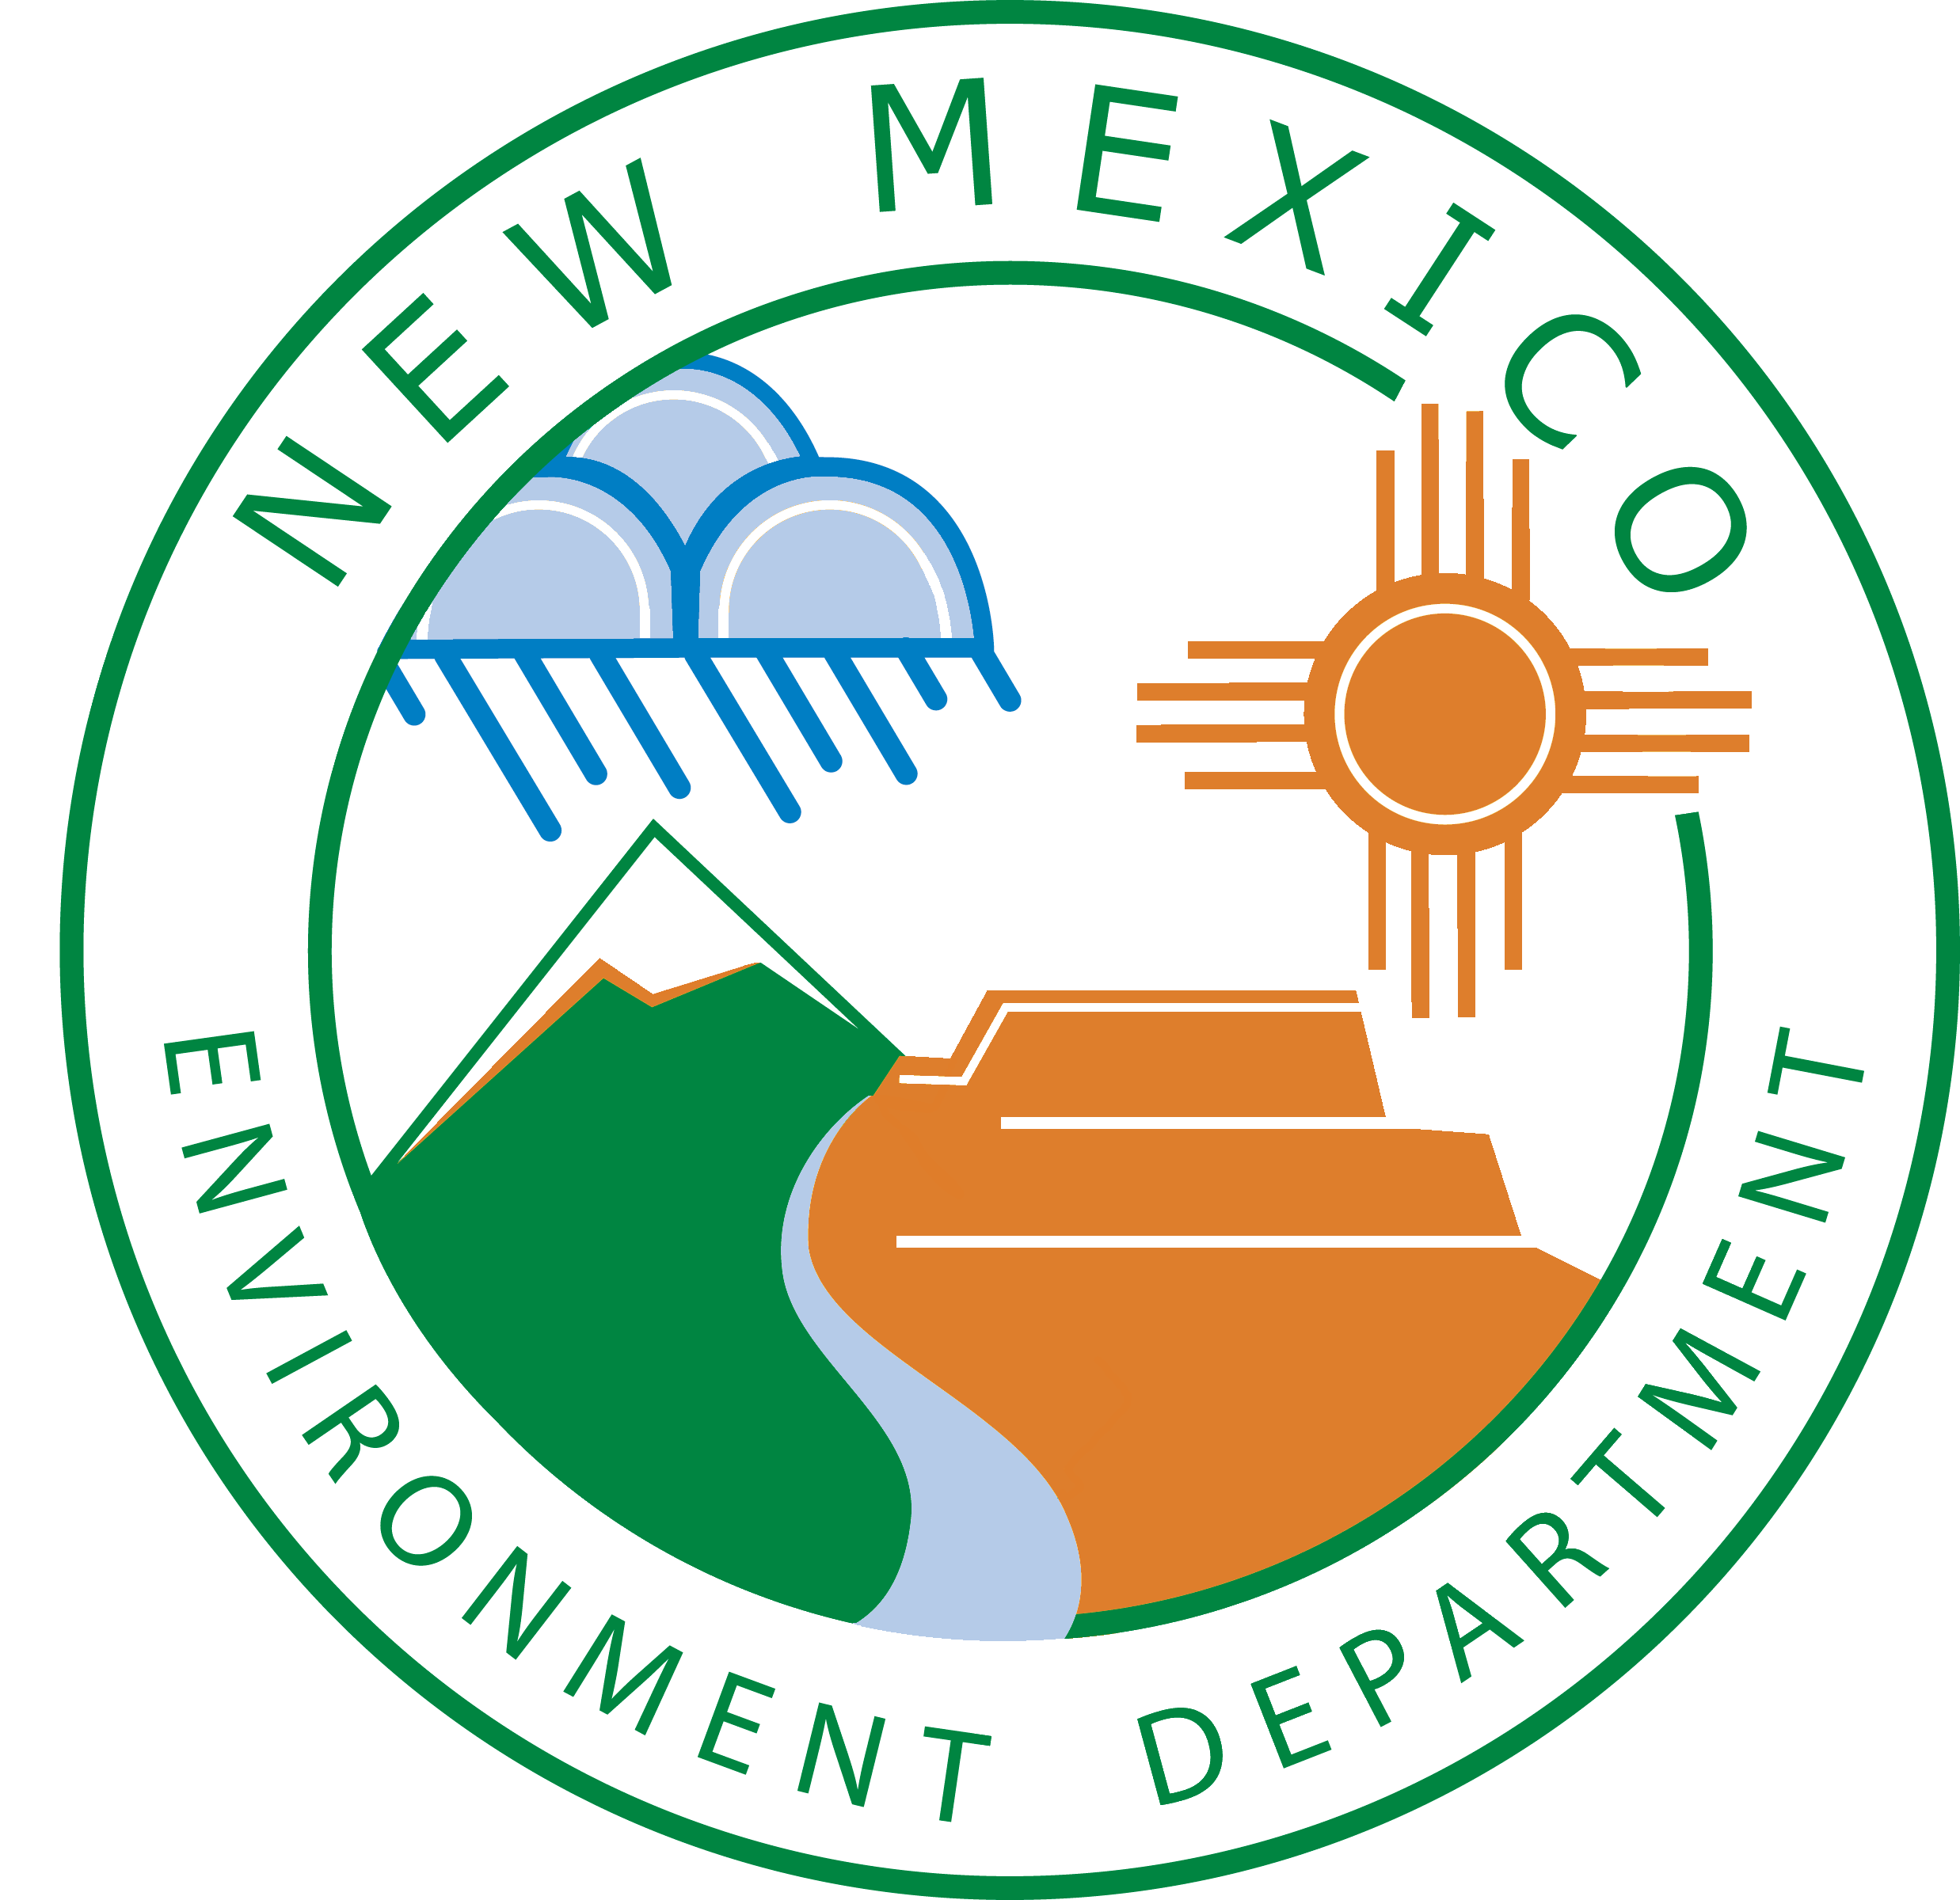 | AQB ePermitting Portal  For Department use only.
Payment Information for Portal Submissions
This form must accompany your check for your AQB ePermitting Portal submittal so that we can easily match payments to applications. We are currently unable to accept electronic payments.
This form and the check can be mailed to the Department while you are still working on an application if you are certain you are going to submit the application through the Portal within 2 business days. Checks are deposited upon receipt.

Your electronic permitting submittal will not be processed until we receive the payment.

Agency ID number*
Owner Company name
Facility Name
Fee type | ☐ GCP-Oil and Gas  Prior to 1/1/2024 ($4,920)  Beginning 1/1/2024 ($5,100) | ☐ Notice of Intent-Oil and Gas ($500)
Check number
Notes (optional)
* Agency ID number can be found at the top of the Portal on any page

For Department Use (A-Team):
- Please date stamp upon receipt.
- Verify amount is correct, scan the date stamped form and check into the ePermitting Portal folder as AI# - Permit type. e.g (39997 – GCP).
- Add notation on list of checks “Portal.”
- Route check for deposit as normal.
- The greybar will be created by the Portal when the project is assigned for review. The assigning manager will move the scan to the folder Ready for Data Stewarding so the check can be applied to the greybar (following your normal process).
- Upload the scanned check & form to the greybar after data stewarding.

